TASK 1
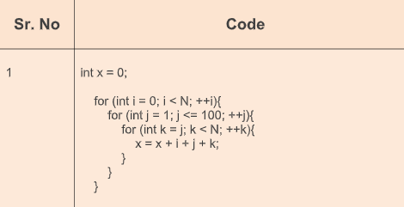
OUTPUT
O(n2)
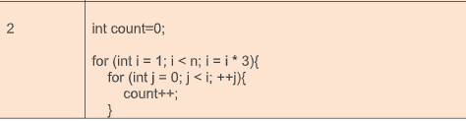
OUTPUT
O(n)
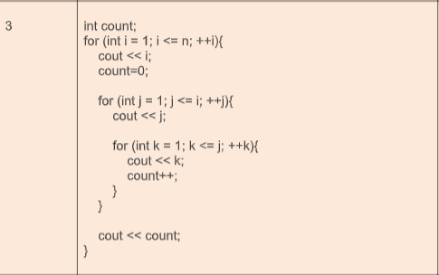
OUTPUT
O(n3)
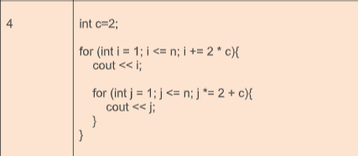
OUTPUT
O(nlogn)
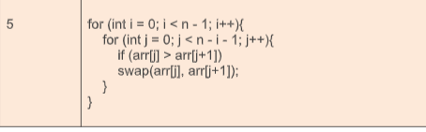
OUTPUT
O(n2)

TASK 2
#include <iostream>
#include <cmath>
#include <limits>
#include <stdexcept>
using namespace std;
class Polynomial {
private:
class Term {
public:
int exponent;
double coefficient;
Term* next;

Term(int exp, double coeff) : exponent(exp), coefficient(coeff), next(nullptr) {}
};
Term* head;
int size;
void Delete() {
Term* temp = head;
while (temp) {
Term* next = temp->next;
delete temp;
temp = next;
}
head = nullptr;
size = 0;
}
void insertTerm(int exp, double Coefficient) {
if (Coefficient == 0) {
return;
}
Term* Newnode = new Term(exp, Coefficient);
if (!head || head->exponent < exp) {
Newnode->next = head;
head = Newnode;
}
else {
Term* current = head;
Term* prevNode = nullptr;
while (current && current->exponent > exp) {
prevNode = current;
current = current->next;
}
if (current && current->exponent == exp) {
current->coefficient += Coefficient;
if (current->coefficient == 0) {
if (prevNode) {
prevNode->next = current->next;
}
else {
head = current->next;
}
delete current;
}
delete Newnode;
return;
}
if (prevNode) {
prevNode->next = Newnode;
Newnode->next = current;
}
else {
Newnode->next = head;
head = Newnode;
}
}
size++;
}
public:
Polynomial() : head(nullptr), size(0) {}
// Copy constructor for creating a deep copy
Polynomial(const Polynomial& other) : head(nullptr), size(0) {
Term* current = other.head;
while (current) {
insertTerm(current->exponent, current->coefficient);
current = current->next;
}
}
~Polynomial() {
Delete();
}
Polynomial& operator=(const Polynomial& other) {
if (this != &other) {
Delete();
Term* current = other.head;
while (current) {
insertTerm(current->exponent, current->coefficient);
current = current->next;
}
}
return *this;
}
void Input() {
Delete();
int numTerms;
cout << "==Enter the number of terms==";
cin >> numTerms;
if (numTerms < 0) throw invalid_argument("Number of terms cannot be negative. Put a positive number");
for (int i = 0; i < numTerms; ++i) {
int exp;
double Coefficient;
cout << "Enter coefficient and exponent: ";
cin >> Coefficient >> exp;
if (cin.fail()) throw invalid_argument("Invalid input for coefficient or exponent.");
insertTerm(exp, Coefficient);
}
}
void Output() {
Term* current = head;
if (!current) {
cout << "0" << endl;
cout << "The list is empty!" << endl;
return;
}
while (current) {
if (current->coefficient != 0) {
if (current != head) {
cout << (current->coefficient > 0 ? " + " : " - ");
}
if (current->exponent == 0) {
cout << abs(current->coefficient);
}
else if (current->exponent == 1) {
cout << abs(current->coefficient) << "n";
}
else {
cout << abs(current->coefficient) << "n^" << current->exponent;
}
}
current = current->next;
}
cout << endl;
}
Polynomial Addfunc(Polynomial& other) {
Polynomial result;
Term* current = head;
Term* otherCurrent = other.head;
while (current && otherCurrent) {
if (current->exponent > otherCurrent->exponent) {
result.insertTerm(current->exponent, current->coefficient);
current = current->next;
}
else if (current->exponent < otherCurrent->exponent) {
result.insertTerm(otherCurrent->exponent, otherCurrent->coefficient);
otherCurrent = otherCurrent->next;
}
else {
result.insertTerm(current->exponent, current->coefficient + otherCurrent->coefficient);
current = current->next;
otherCurrent = otherCurrent->next;
}
}
while (current) {
result.insertTerm(current->exponent, current->coefficient);
current = current->next;
}

while (otherCurrent) {
result.insertTerm(otherCurrent->exponent, otherCurrent->coefficient);
otherCurrent = otherCurrent->next;
}

return result;
}
Polynomial operator+(Polynomial& other) {
return Addfunc(other);
}
Polynomial Multiplyfunc(Polynomial& other) {
Polynomial result;
Term* current = head;
while (current) {
Term* otherCurrent = other.head;
while (otherCurrent) {
result.insertTerm(current->exponent + otherCurrent->exponent, current->coefficient * otherCurrent->coefficient);
otherCurrent = otherCurrent->next;
}
current = current->next;
}
return result;
}
Polynomial operator*(Polynomial& other) {
return Multiplyfunc(other);
}
double Evaluatefunc(double x) {
double result = 0;
Term* current = head;
while (current) {
result += current->coefficient * pow(x, current->exponent);
current = current->next;
}
return result;
}

double operator()(double x) {
return Evaluatefunc(x);
}
};
int main() {
try {
Polynomial p1, p2;
cout << "Input for Polynomial 1:\n";
p1.Input();
cout << "Input for Polynomial 2:\n";
p2.Input();
cout << "Polynomial 1: ";
p1.Output();
cout << "Polynomial 2: ";
p2.Output();
Polynomial sum = p1 + p2;
cout << "Sum: ";
sum.Output();
Polynomial product = p1 * p2;
cout << "Product: ";
product.Output();
double x;
cout << "||Enter a value for x to evaluate the polynomials||";
cin >> x;
cout << "Polynomial 1 evaluated at x = " << x << ": " << p1(x) << endl;
cout << "Polynomial 2 evaluated at x = " << x << ": " << p2(x) << endl;
cout << "Sum evaluated at x = " << x << ": " << sum(x) << endl;
cout << "Product evaluated at x = " << x << ": " << product(x) << endl;
}
catch (const exception& ex) {
cerr << "Error: " << ex.what() << endl;
}
return 0;
}
TASK 2 OUTPUT
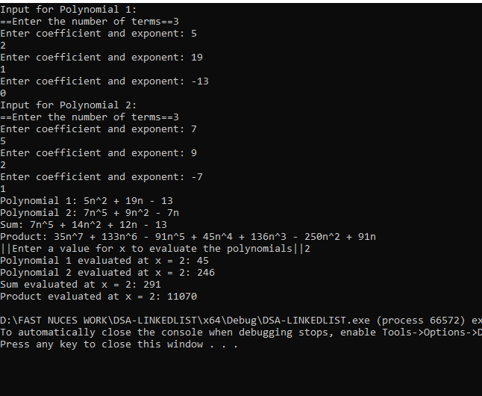

TASK 3
#include <iostream>
#include <string>
using namespace std;
class userAction {
public:
string description;
userAction* next;
userAction* prev;
userAction(const string& act) : description(act), next(nullptr), prev(nullptr) {}
};
class undoRecord {
public:
string description;
undoRecord* next;
undoRecord(const string& act) : description(act), next(nullptr) {}
};
class undoManager {
public:
undoRecord* head;
undoManager() : head(nullptr) {}
void addUndo(const string& act) {
undoRecord* newUndo = new undoRecord(act);
newUndo->next = head;
head = newUndo;
cout << "||ACTION ADDED TO REDO LIST||" << endl;
}
void deleteUndo() {
if (head) {
undoRecord* temp = head;
head = head->next;
delete temp;
cout << "||ACTION DELETED FROM A REDO LIST||" << endl;
}
}
};
class HistoryManager {
private:
int size;
undoManager undoManager;
userAction* head;
userAction* recentAction;
public:
HistoryManager() : head(nullptr), recentAction(nullptr), size(0) {}
void addAction(const string& act) {
userAction* newAction = new userAction(act);
if (!head) {
head = recentAction = newAction;
}
else {
recentAction->next = newAction;
newAction->prev = recentAction;
recentAction = newAction;
}
size++;
cout << "Action \"" << act << "\" added." << endl;
}
void undoAction() {
if (!recentAction) {
cout << "No action performed, nothing to undo." << endl;
return;
}
undoManager.addUndo(recentAction->description);
userAction* temp = recentAction;
recentAction = recentAction->prev;
if (recentAction) {
recentAction->next = nullptr;
}
else {
head = nullptr;
}
delete temp;
cout << "Action successfully undone." << endl;
}
void redoAction() {
if (!undoManager.head) {
cout << "No action to redo; redo list is empty." << endl;
return;
}
addAction(undoManager.head->description);
undoManager.deleteUndo();
cout << "Action successfully redone." << endl;
}

void deleteSpecificAction(int pos) {
if (!head) {
cout << "No actions performed; empty list!" << endl;
return;
}
if (pos <= 0) {
cout << "Invalid position!" << endl;
return;
}
userAction* traverse = head;
for (int i = 1; i < pos && traverse != nullptr; ++i) {
traverse = traverse->next;
}
if (!traverse) {
cout << "Position exceeds the length of the list." << endl;
return;
}
if (traverse == head) {
head = head->next;
if (head) {
head->prev = nullptr;
}
}
else {
if (traverse->next) {
traverse->next->prev = traverse->prev;
}
if (traverse->prev) {
traverse->prev->next = traverse->next;
}
}
if (traverse == recentAction) {
recentAction = traverse->prev;
}
delete traverse;
size--;
cout << "Action deleted successfully." << endl;
}

void getRecentAction() const {
if (!recentAction) {
cout << "No actions performed yet." << endl;
return;
}
cout << "Most recent action: \"" << recentAction->description << "\"" << endl;
}

void revertUndo(int index) {
if (!head) {
cout << "Action history is empty." << endl;
return;
}
userAction* traverse = head;
int len = 0;
while (traverse) {
len++;
traverse = traverse->next;
}
if (index > len || index <= 0) {
cout << "Invalid index." << endl;
return;
}
while (len > index) {
undoAction();
len--;
}
cout << "Reverted action: \"" << recentAction->description << "\"" << endl;
}

void revertRedo(int index) {
if (!head || !undoManager.head) {
cout << "Action history or redo list is empty." << endl;
return;
}
userAction* traverse = head;
int len = 0;
while (traverse) {
traverse = traverse->next;
len++;
}
if (index > size || index <= 0) {
cout << "Invalid index." << endl;
return;
}
while (len < index) {
redoAction();
len++;
}
cout << "Reverted action: \"" << recentAction->description << "\"" << endl;
}

void browseHistory() const {
userAction* traverse = head;
cout << "Action History:" << endl;
int i = 1;
while (traverse) {
cout << "Action " << i << ": \"" << traverse->description << "\"" << endl;
traverse = traverse->next;
i++;
}
}
};
void displayMenu() {
cout << "======================" << endl;
cout << " ACTION MANAGER " << endl;
cout << "======================" << endl;
cout << "1. Adding Action" << endl;
cout << "2. Undo Action" << endl;
cout << "3. Redo Action" << endl;
cout << "4. Deleting Specific Action" << endl;
cout << "5. Get Recent Action" << endl;
cout << "6. Revert Actions Undo" << endl;
cout << "7. Revert Actions Redo" << endl;
cout << "8. Browse History" << endl;
cout << "9. Exit" << endl;
cout << "======================" << endl;
}
int main() {
HistoryManager Manager;
while (true) {
displayMenu();
cout << "Enter your choice: ";
int choice;
cin >> choice;
switch (choice) {
case 1: {
string action;
cout << "Enter the action to add: ";
cin.ignore();
getline(cin, action);
Manager.addAction(action);
break;
}
case 2:
Manager.undoAction();
break;
case 3:
Manager.redoAction();
break;
case 4: {
int pos;
cout << "Enter the position to delete: ";
cin >> pos;
Manager.deleteSpecificAction(pos);
break;
}
case 5:
Manager.getRecentAction();
break;
case 6: {
int index;
cout << "Enter the number of actions to revert undo: ";
cin >> index;
Manager.revertUndo(index);
break;
}
case 7: {
int index;
cout << "Enter the number of actions to revert redo: ";
cin >> index;
Manager.revertRedo(index);
break;
}
case 8:
Manager.browseHistory();
break;
case 9:
cout << "||Exiting.....THANKYOU FOR USING||" << endl;
return 0;
default:
cout << "Invalid choice! Please try again." << endl;
break;
}
system("pause");
}
}

TASK 3 OUTPUT
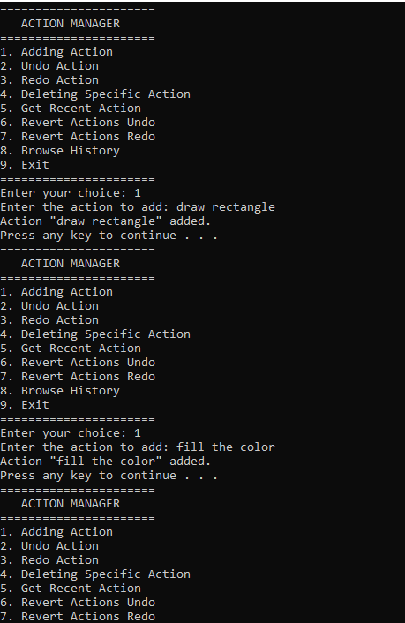
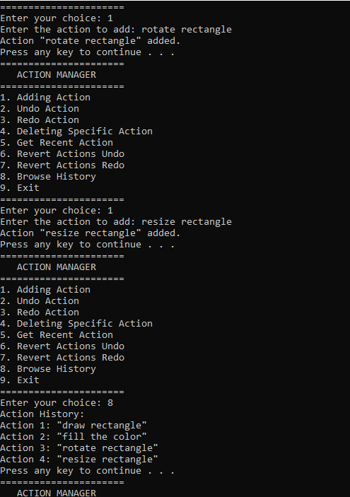

TASK 4
#include <iostream>
#include <limits> // For input validation
using namespace std;
struct Node {
int data;
Node* next;
Node* prev;
// Pointer to child list
Node* child;
// Constructor for a new node
Node(int val) {
data = val;
next = nullptr;
prev = nullptr;
child = nullptr;
}
};
// Function to flatten the doubly linked list
Node* flatten(Node* head) {
if (!head) return head;

Node* current = head;
while (current) {
// If the current node has a child, we need to flatten that part
if (current->child) {
// Find the tail of the child list
Node* childTail = current->child;
while (childTail->next) {
childTail = childTail->next;
}
// Attach the child list after the current node and before the next node
if (current->next) {
current->next->prev = childTail;
}
childTail->next = current->next;
current->next = current->child;
current->child->prev = current;
// Set the child pointer to null after flattening
current->child = nullptr;
}
current = current->next;
}

return head;
}
void printList(Node* head) {
if (!head) {
cout << "The list is empty.\n";
return;
}

Node* current = head;
cout << "List: ";
while (current) {
cout << current->data << " ";
current = current->next;
}
cout << endl;
}

// Function to insert nodes at the end of the doubly linked list
Node* insert(Node* head, int data) {
Node* newNode = new Node(data);
if (!head) return newNode;

Node* current = head;
while (current->next) {
current = current->next;
}

current->next = newNode;
newNode->prev = current;
return head;
}
// Function to create a child list for a node
void createChildList(Node* parent)
{
int numChildren;
while (true) {
cout << "Enter the number of children to add to node " << parent->data << ": ";
cin >> numChildren;

if (cin.fail() || numChildren < 0) {
cout << "Invalid input. Please enter a non-negative integer.\n";
cin.clear();
cin.ignore(numeric_limits<streamsize>::max(), '\n');
}
else {
break;
}
}
if (numChildren == 0) return;
cout << "Enter the values of the children:\n";
for (int i = 0; i < numChildren; ++i)
{
int childData;
while (true) {
cout << "Child " << (i + 1) << ": ";
cin >> childData;

if (cin.fail()) {
cout << "Invalid input. Please enter an integer value.\n";
cin.clear();
cin.ignore(numeric_limits<streamsize>::max(), '\n');
}
else {
break;
}
}

parent->child = insert(parent->child, childData);
}
}
Node* findNode(Node* head, int data) {
Node* current = head;
while (current && current->data != data) {
current = current->next;
}
return current;
}
int getMenuChoice() {
int choice;
while (true) {
cout << "Enter your choice: ";
cin >> choice;

if (cin.fail() || choice < 1 || choice > 5) {
cout << "Invalid input. Please enter a number between 1 and 5.\n";
cin.clear();
cin.ignore(numeric_limits<streamsize>::max(), '\n');
}
else {
break;
}
}
return choice;
}
int getNodeData(const string& prompt) {
int data;
while (true) {
cout << prompt;
cin >> data;

if (cin.fail()) {
cout << "Invalid input. Please enter an integer value.\n";
cin.clear();
cin.ignore(numeric_limits<streamsize>::max(), '\n');
}
else {
break;
}
}
return data;
}
int main() {
Node* head = nullptr;
int choice;

do {
cout << "||MENU BELOW||\n";
cout << "1.ADD NODE AT TAIL\n";
cout << "2. CREATE CHILD LIST FOR PARTICULAR NODE\n";
cout << "3. FLATTEN THE LIST\n";
cout << "4. PRINT THE LIST\n";
cout << "5. Exit......\n";
choice = getMenuChoice();
switch (choice) {
case 1: {
int data = getNodeData("Enter the value for the new node: ");
head = insert(head, data);
break;
}
case 2: {
int parentData = getNodeData("Enter the value of the parent node: ");

Node* parent = findNode(head, parentData);
if (parent) {
createChildList(parent);
}
else {
cout << "Node with value " << parentData << " not found.\n";
}
break;
}
case 3: {
if (head) {
head = flatten(head);
cout << "The list has been flattened.\n";
}
else {
cout << "The list is empty. Nothing to flatten.\n";
}
break;
}
case 4: {
printList(head);
break;
}
case 5:
cout << "Exiting...\n";
break;
}
} while (choice != 5);

return 0;
}
TASK 4 OUTPUT
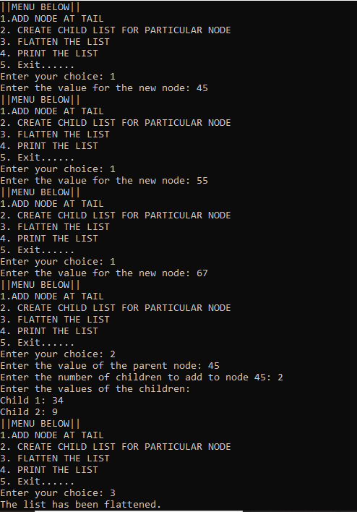
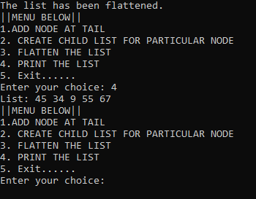

TASK 5
#include <iostream>
using namespace std;
class Node {
public:
int fileId;
Node* next;
Node(int fileId) : fileId(fileId), next(nullptr) {}
};
class Cache {
private:
Node* head;
Node* tail;
int size;
public:
Cache() : head(nullptr), tail(nullptr), size(0) {}
void addFileId(int fileId) {
Node* newNode = new Node(fileId);
if (head == nullptr) {
head = newNode;
tail = newNode;
newNode->next = head;
}
else {
tail->next = newNode;
newNode->next = head;
tail = newNode;
}
size++;
}
void moveToFront(int fileId) {
if (head == nullptr) return;
Node* current = head;
Node* previous = nullptr;
while (current->next != head && current->fileId != fileId) {
previous = current;
current = current->next;
}
if (current->fileId == fileId) {
if (current == head) return;
previous->next = current->next;
current->next = head;
head = current;
tail->next = head;
}
}
void printList() {
if (head == nullptr) {
cout << "Cache is empty." << endl;
return;
}
Node* current = head;
cout << "Current cache state: ";
do {
cout << current->fileId << " ";
current = current->next;
} while (current != head);
cout << endl;
}
};
int main() {
Cache cache;
int numFiles;
cout << "Enter the number of file IDs to add to the cache: ";
cin >> numFiles;
for (int i = 0; i < numFiles; ++i) {
int fileId;
cout << "Enter file ID " << (i + 1) << ": ";
cin >> fileId;
cache.addFileId(fileId);
}
cache.printList();
char continueAccess;
do {
int fileId;
cout << "Enter the file ID to access and move to the front: ";
cin >> fileId;
cache.moveToFront(fileId);
cache.printList();
cout << "Do you want to access another file? (y/n): ";
cin >> continueAccess;
} while (continueAccess == 'y' || continueAccess == 'Y');
return 0;
}

TASK 5 OUTPUT
